|  |  |  |
| --- | --- | --- |
| **Course : Web Programming Principles -WEB222** | **Assignment 3 of 3** | **Contribution:10% of course** |
| **Prof: Kadeem Best** | **Date Given: 1st December 2020** | **Date Due:12th December 2020** |

**Notes for the Student:** Notes for the Student: This Assignment is designed to give you practical experience in building a modern looking website using native HTML5, CSS3 and JavaScript code.

**Assignment Submission Requirements**

* An electronic copy of your work should be uploaded to Blackboard by midnight on the deadline date.
* The link to the movie website that you would be emulating. (Note: you MUST select an existing movie website and emulate its design based on the requirements that I specified below)
* A link to a recorded video of you detailing the demonstration of your website.
* **This Assignment will not be accepted via email**

**Late Penalties**

* *NO LATE SUBMISSION*

**ACADEMIC INTEGRITY**

Sharing your code and project to other students is **not permitted**. Any learner suspected of breaking the above rules will not have their submission marked; and, a report will be filed with the College’s Academic Integrity department.

To prevent issues of academic integrity, it is imperative that you are vigilant that your code is not duplicated, in part or whole, by another learner. Duplication can mean: identical code; or code that is semantically identical in naming and overall construction. Should the instructors discover academic dishonesty as defined above and per the College Academic Integrity Policies, **a grade of 0** will be assigned to all parties involved.

*Please review Seneca’s policies on Academic Integrity, specifically:“Each student should be aware of the College's policy regarding Cheating and Plagiarism. Seneca's Academic Policy will be strictly enforced.To support academic honesty at Seneca College, all work submitted by students may be reviewed for authenticity and originality, utilizing software tools and third party services. Please visit the Academic Honesty site on http://library.senecacollege.ca for further information regarding cheating and plagiarism policies and procedures.*

# 

# **Detailed Specification**

**This assessment must be completed individually.**

This assignment is a continuation of Assignment 2, thus all the requirements for this assignment is to be made “on top” of your Assignment 1.

## **Responsiveness (10 marks)**

You are to make your Home Page and Now Playing pages responsive. Note, for this assignment, you are only required to make it look good for desktop and mobile devices. Thus, you should **only** write media queries breakpoints for smartphone devices given that Assignment 1 you would have already developed your website to look good for desktop and large screen devices.

## **Automatic Image Carousel (10 marks)**

You are to convert your Hero section from a static image to an automatic image carousel that switches between images every 5 seconds. Note that your image carousel must have at least 5 images. Each image must be sized the same(via code) so that it looks uniform.

Lastly, your image carousel must have two arrows, a left arrow and a right arrow. This is used to control the direction of the images. If the left arrow is clicked then your image carousel should reverse the direction the images are flowing. Whereas, if the right arrow is clicked then the direction of the image should return to the original flow.

The automatic image carousel should flow similarly to the image carousel on <https://www.amctheatres.com/> **Hero Section**

Example :

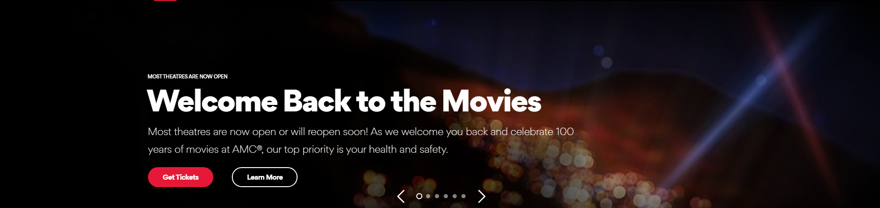

## 

## **Movie Details Page (10 marks)**

**Convert the movie details page from a separate page into a WELL DESIGN popup modal**. Thus, on the Now Playing Movies page, when the user clicks on a poster image, a popup modal must be displayed. The popup modal should display all the pertinent information of the clicked movie. The Information should include : movie title, ratings, overview, featured crew, the latest movie page and the link to the trailer of the movie. The modal should also have an X . When the X is pressed, the modal should be “closed.”

**THE END**